Names: Thabiso Matsaba
Ethan Lesar
Student Number: 220296006
220112010
Course: ICT Electives 2
Course Code: ICE260S
Assignment: Group 1 Project
Lecturer: Miss Madaniyah Mohamed
Due Date: 26 September 2021

Artificial Intelligence in Medicine

Prepared for
Miss Madaniyah Mohamed
Cape Peninsula University of Technology

Prepared by
Thabiso Matsaba
Ethan Lesar

26 September, 2021

TABLE OF CONTENTS
Page

TABLE OF CONTENTS……............................................................................... i
SECTION 1
Summary Report..................................................................................................... 1
................................................................................................................................ 2
SECTION 2
Problem Identification.............................................................................................. 3
…………………………………………………………………………………….. 4
SECTION 3
Application of AI...................................................................................................... 4
……………………………………………………………………………………... 5
……………………………………………………………………………………... 6
SECTION 4
Implementation......................................................................................................... 7
……………………………………………………………………………………. 8
SECTION 5
Bibliography............................................................................................................. 9
…………………………………………………………………………………….. 10
Section 1
Artificial Intelligence in Medicine
Summary Report
Alan Turing (1950) was one of the founders of modern computers and AI. The "Turing test" was based on the fact that the intelligent behavior of a computer is the ability to achieve human-level performance in cognitive tasks. In 2016, the biggest chunk of investments in AI research was in healthcare applications compared with other sectors. Artificial intelligence (AI) in medicine can be classified into two main parts: virtual and physical. The physical part deals with robots assisting in performing surgeries, intelligent prostheses for the disabled and elderly, and care for people with physical or cognitive impairments.
The basis of evidence-based medicine is to establish clinical correlations and insights via development. patterns and associations from the existing database of information. Computers learn the art of diagnosing a patient via two broad techniques - flowcharts and database approach. The flowchart approach involves translating the process of history-taking into a probable diagnosis by combining the symptom complex presented. The database approach utilizes the principle of deep learning or pattern recognition.
A lot of AI is already being utilized in the medical field, ranging from online scheduling of appointments to drug dosage algorithms and adverse effect warnings while prescribing multidrug combinations. The use of CAD (computer-assisted diagnosis) in screening is well known. AI could also aid in radiology by not only labeling abnormal exams but also by identifying quick negative exams in X-rays and magnetic resonance images, especially in high-volume settings. A decision support system known as DXplain was developed by the University of Massachusetts in 1986. Germwatcher and AI-therapy are online courses that help patients treat their social anxiety using a therapeutic approach of cognitive behavior therapy. In the UK, Babylon can be used by the patients to consult the doctor online, check for symptoms, get advice, monitor their health, and order test kits.
The Da Vinci robotic surgical system developed by Intuitive surgical has revolutionized the field of urological and gynecological surgeries. Buoy Health and the Boston children's hospital are working on a web interface-based AI system that provides advice to parents for their ill children. The National Institute of Health has created an AiCure App, which monitors the use of medications by the patient via smartphone webcam access and hence reduces nonadherence rates. IBM's Watson Health will be equipped to efficiently identify symptoms of heart disease and cancer. Stanford University is making a program AI-assisted care (PAC) PAC has intelligent senior wellbeing support and smart ICU, which will sense any behavioral changes in elderly people living alone[14] and hospital patients. Hand hygiene support is using computer vision technology to achieve perfect hand hygiene for clinicians and reducing hospital-acquired infections. Molly is a virtual nurse\rthat is being developed to provide follow-up care to discharged patients allowing doctors to focus on more\rpressing cases.
A study conducted in 2016[17] found that physicians spent 27% of their office day on direct clinical face-time with their patients and 49.2% on electronic hospital records and desk work. Increased AI usage in medicine not only reduces manual labor and frees up the primary care physician's time but also increases productivity, precision, and efficacy. These applications will collect and analyze patient data and present it to primary care physicians alongside insight into patient's medical needs. With the help of artificial intelligence (AI), we would be able to embrace the new concept of "precision medicine" - where every aspect of our health and well-being is mapped out in advance. For example, AI was used to screen existing medications, which could be used to fight against the emerging Ebola virus menace which would have taken years to process otherwise. Artificial intelligence (AI) has potential, but it is unlikely that AI will replace doctors out rightly.
In 2016, the Digital Mammography DREAM Challenge was done where several networks of computers reviewed 640,000 digital mammograms. Analytically and logically machines may be able to translate human behavior, but certain human traits such as critical thinking, interpersonal and communication skills, emotional intelligence, and creativity cannot. honed by machines. Primary care physicians need to be well versed with the future AI advances and the new unknown territory the world of medicine is heading toward. The goal should be to strike a mutually beneficial balance between the effective use of automation and AI and the human strengths and judgment of trained primary care physicians.
Medical professionals also need to understand and acclimatize themselves with these advances for better healthcare delivery to the masses

Section 2
Problem Identification

In the healthcare profession, many people have serious illnesses that require diagnoses from a doctor or specialist for them to be treated accurately and sometimes human error is an issue, and it is a problem that some patients face when going to a doctor or when the wrong medicine is prescribed. This may not work or even be detrimental to the patient. According to healthline.com almost 50000 to 80000 people die in the US of misdiagnoses (SIDM,2018). This is alarming, not only for the number of people that are dying but also for those people paying medical aid and state healthcare being at fault due to human error. Misdiagnoses can also lead to other illnesses which can be detrimental to humans. Many illnesses are hard to diagnose and so an AI agent can pick up the correct disease, which can be done using image-capturing and analysis, there are also many diseases that are difficult to diagnose, these include lupus, lime disease, and multiple sclerosis (Robinson,2021).
I believe that this problem can be solved using AI. Due to AIs’ use of machine learning and expert systems. There are already expert systems that have been creating to improve the diagnosis process, the implementation should not be difficult as there is information readily available “ The need for diagnostic decision support systems for assisting medical providers has been well understood for a long time.”(Kannan,2019) I believe that an AI system could analyse data about diagnoses and find correlations and identify areas of similarity, this could be done like a doctor. Another common problem is self-diagnosis, and this contributes to the need for an AI-based application which will relieve the inaccuracy of people that are using google and other sources, according to etactics.com mixing of medicine and misdiagnoses is the biggest issue with this (Clark,2020).
An expert system will solve this problem from the comfort of your home using images and questionnaires. The covid 19 pandemic has also created a greater need for this because people fear being outside and sometimes the most infectious place to go is the doctor. This has made healthcare professional uses WhatsApp and other social to diagnose patients using the platforms, according to whatsapp.com they have heightened security measures to help make this a safe means of communication. The simplest way I can see this happening is when there is a database system when patient diagnoses are entered, and the system finds other patients with similar traits and outputs a diagnosis. This information be prerequisite into the system essentially creating an expert system this will help doctors to not have errors natural language processing will also help with this as it is.
Misdiagnosis cannot be done without a doctor and consultation with even an application that can help this and even cut out having to see a doctor. This healthy person who cannot see a doctor and can take out the hefty consultation fee. This alleviates a lot of unnecessary conveyances the patient may experience. An application can be used as an expert system with several diagnoses levels with a serious illness can recommend further human expectation.
Section 3
Application of Artificial Intellingence
The Design of an Medical Diagnosis Agent
- Agent: Medical diagnosis
- Performance measure:
- Health of patients increases
- Minimize costs of misdiagnosis
- Less death in patients
- Aviod lawsuits
- Enviroment:
- Patient
- Hospital
- Staff/Doctors
- Actuators:
- Screen Display (questions, records, tests, diagnosis, treatments and referals)
- Sensors:
- Keyboard (entry of symptoms, findings and patient answers)
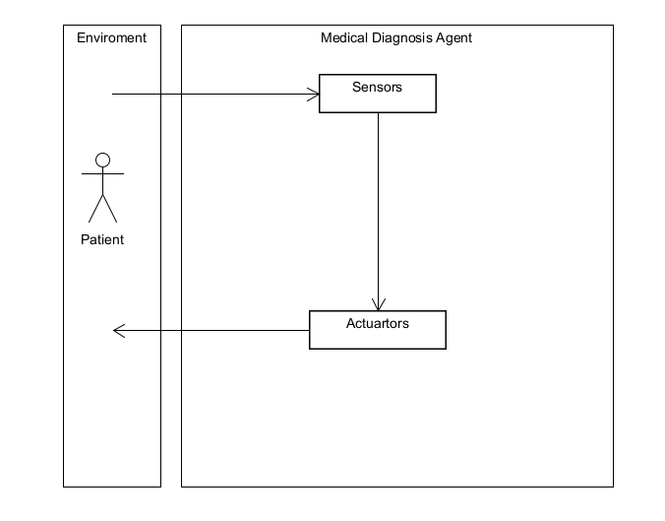
Figure 1: Medical Diagnosis Agent
- State space representation of the agent:
The first equation is called the state equation, the second equation is called the output equation. For an n^{th} order system (i.e., it can be represented by an n^{th} order differential equation) with r inputs and m outputs the size of each of the matrices is as follows:
- q is nx1 (n rows by 1 column); q is called the state vector, it is a function of time
- A is nxn; A is the state matrix, a constant
- B is nxr; B is the input matrix, a constant
- u is rx1; u is the input, a function of time
- C is mxn; C is the output matrix, a constant
- D is mxr; D is the direct transition (or feedthrough) matrix, a constant
- y is mx1; y is the output, a function of time
Note several features:
- The state equation has a single first order derivative of the state vector on the left, and the state vector, q(t), and the input u(t) on the right. There are no derivatives on the right hand side.
- The output equation has the output on the left, and the state vector, q(t), and the input u(t) on the right. There are no derivatives on the right hand side.
For systems with a single input and single output (i.e., most of the systems we will consider) these variables become (with r=1 and m=1):
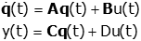
where
- q is nx1 (n rows by 1 column)
- A is nxn
- B is nx1
- u is 1x1 (i.e., a scalar)
- C is 1xn
- D is 1x1 (i.e, a scalar)
- y is 1x1 (i.e, a scalar)
- Consider an 4th order system represented by a single 4th order differential equation with input x and output z.

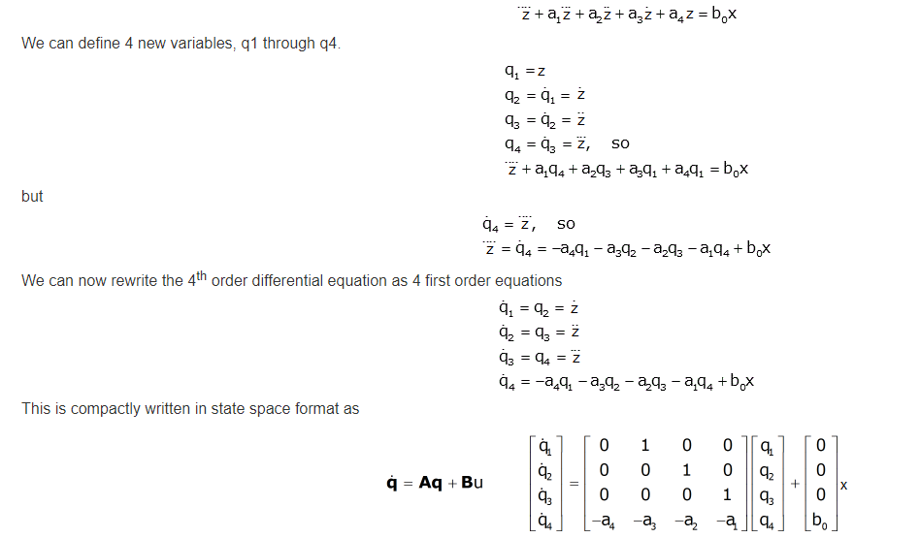

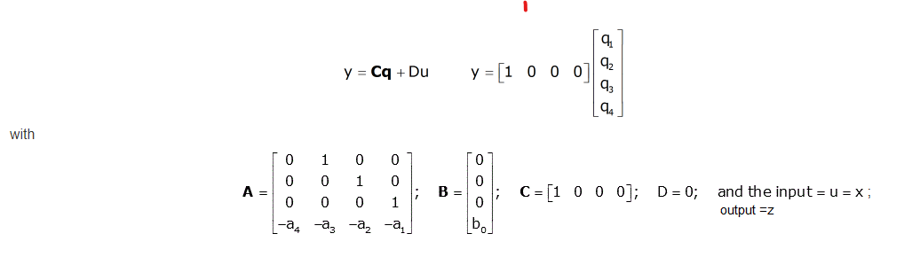
- The model of knowledge representation required would be Logic representation. Method in which we provide sample labeled data to the machine learning system in order to train it, and on that basis, it predicts the output. The algorithm needs to act on that data without any supervision. The system creates a model using labeled data to understand the datasets and learn about each data, once the training and processing are done then we test the model by providing a sample data to check whether it is predicting the exact output or not.

Section 4
Application of Agent
- The Medical Diagnosis system will need the following to fully fucntion in the real world:
The Medical diagnosis agent will need a hospital database to iterate and sequence patients medical records to train the AI agent and to ensure the agent has all the information and knowledge it needs to solve misdiagnosis in patients. the data of the database must be structured data that conforms to a rigid format to ensure consistency in processing and also ease of analytics.
The agent will need a very good programming language like Java or Phython to code the neccesarry algorithms and APIs to implement the system in medical enviroments. These coding languages offer a strong set of tools including extensive Machine Learning libraries to the users. One of the very useful libraries is NLTK — the natural language tool kit written in Python instead of programming it all by yourself.
The popular platforms for which the Medical daignosis agent can be bulit on include Microsoft Azure Machine Learning, Google Cloud Prediction API, TensorFlow, Ayasdi just to name a few. These platforms offer the necessary tools and built in engines to build, test and deploy AI systems in the real world.
Our agent or system will adopt and implement Supervised Learning from Machine Learning. Supervised learning is a process of providing input data as well as correct output data to the machine learning model. The aim of a supervised learning algorithm is to find a mapping function to map the input variable(x) with the output variable(y). In supervised learning, models are trained using labelled dataset, where the model learns about each type of data. Once the training process is completed, the model is tested based on test data (a subset of the training set), and then it predicts the output.
The algorithm or agent our system will use is the Regression Analysis algorithm. Regression Analysis is a supervised learning technique which helps in finding the correlation between variables. Enables us to predict the continuous output variable based on the one or more predictor variables. Linear regression is a statistical regression method which is used for predictive analysis. It is one of the very simple and easy algorithms which works on regression and shows the relationship between the continuous variables. It is used for solving the regression problem in machine learning. Linear regression shows the linear relationship between the independent variable (X-axis) and the dependent variable (Y-axis), hence called linear regression.
Supervised Macine Learning works best for our system as it needs to predict the diseaseses, sicknesses and causes of illness in patients. With the help of supervised learning, the model can predict the output based on prior experiences. In supervised learning, we can have an exact idea about the classes of objects needed .

BIBLIOGRAPHY

Artificial Intelligence [online] Slide share
https://www.slideshare.net/vinodkumarmeghwar/artificial-intelligence-59412935
[Accessed 20 September 2021]

Artificial Intelligence
Understanding PEAS in Artificial Intelligence [online]
https://paloaltoexam.blogspot.com/2020/08/understanding-peas-in-artificial-intelligence.html
[Accessed 19 September 2021]

Clark, M (2020) 9 Problems With And Dangers Of Self Diagnosis.[online] Etactics
https://etactics.com/blog/problems-with-self-diagnosis
[Accessed 23 September 2021]

How to implement AI and machine learning [online]
https://www.techrepublic.com/article/how-to-implement-ai-and-machine-learning/
[Accessed 20 September 2021]

How WhatsApp can help you stay connected during the coronavirus (COVID-19) pandemic [Online] WhatsApp
https://www.whatsapp.com/coronavirus/healthcare/
[Accessed 24 September 2021]

Kannan, A (2019) The science of assisting medical diagnosis: From Expert systems to Machine-learned models[online] Medium
https://medium.com/curai-tech/the-science-of-assisting-medical-diagnosis-from-expert-systems-to-machine-learned-models-cc2ef0b03098
[Accessed 23 September 2021]

Robinson, S (2021).Condition That Are Hard To Diagnose.[online] Webmd
https://www.webmd.com/a-to-z-guides/ss/slideshow-hard-to-diagnose
[Accessed 22 September, 2021]

State Space Representations of Linear Physical Systems [online]
https://lpsa.swarthmore.edu/Representations/SysRepSS.html
[Accessed 22 September 2021]

State-Space Search [online]
https://sites.fas.harvard.edu/~cscie119/lectures/search.pdf
[Accessed 21 September 2021]

Why Getting Medically Misdiagnosed Is More Common Than You Think.[Online] HealthLine News
https://www.healthline.com/health-news/many-people-experience-getting-misdiagnosed
[Accessed 20 September 2021]

